Xiaoting Lian

3/7/2021

Since I’m using windows, I installed PuTTY in my PC. First thing I had to do after install PuTTY is email Professor Raymond to get my username and passwords.

Some of the useful command inputs

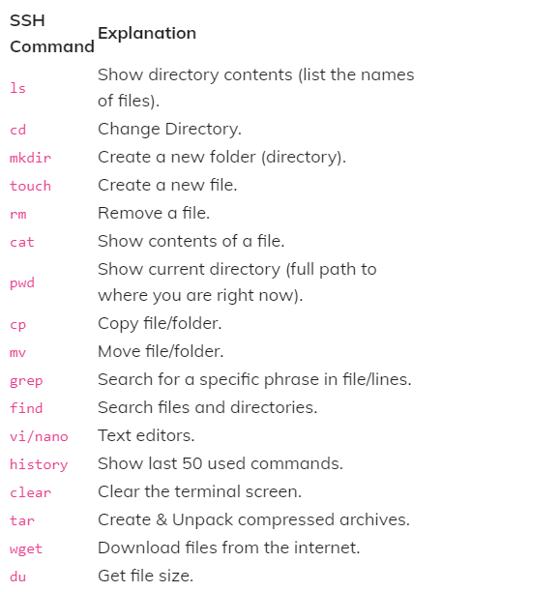

I had experiences with VIM, and I did some research about how vim works and input some commands to see how it responds. After input “vim” it will show the vim versions and some helps commands on the screen

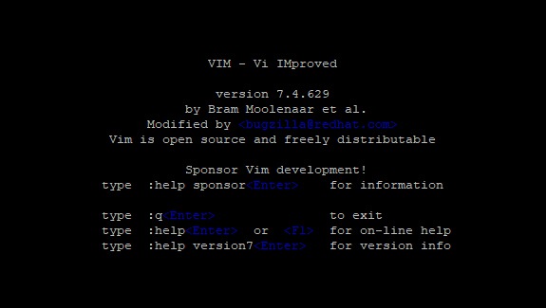

In order to allow input, I have to press I, as insert. After inserting press ESC key to back to the command line, and you can save whatever you wrote by input ”:w + (the file name)” after save your file, you can go back to the beginning by input “:q”, at this point, you can type in “ls” to see all the file in your current directory. In my case, since I have only one text file, so I only have one.

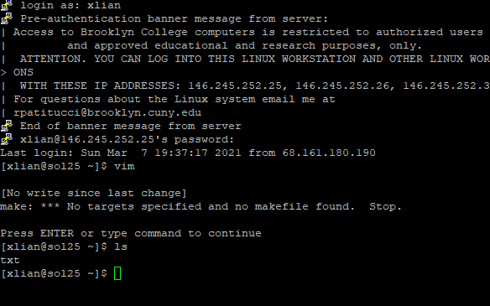

If you can CPP file in your directory and you want to run it the input is “g++ -o myCode myCode.cpp”

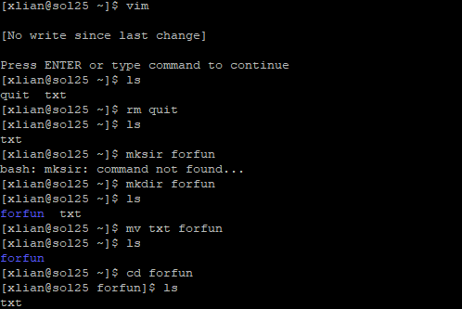

The above image shows I created two files, txt and quit. “rm quit” removed quit file from the list, and then I created a directory, forfun and moved txt file to forfun. And change the directory to for fun by input “ cd forfun” and input ls again, it shows the txt file now is under forfun directory.